**Declaration Sheet**

**Award Title:*BSc (Hons) Computer Science***

(Presented in partial fulfillment of the assessment requirements for the above award.)

This work or any part thereof has not previously been presented in any form to the University or to any other institutional body whether for assessment or for other purposes. Save for any express acknowledgements, references and/or bibliographies cited in the work. I confirm that the intellectual content of the work is the result of my own efforts and of no other person.

It is acknowledged that the author of any project work shall own the copyright. However, by submitting such copyright work for assessment, the author grants to the University a perpetual royalty-free license to do all or any of those things referred to in section 16(I) of the Copyright Designs and Patents Act 1988.  (viz. to copy work; to issue copies to the public; to perform or show or play the work in public; to broadcast the work or to make an adaptation of the work).

Student Name: **Sandip Thapa**

Student ID Number: **2039244**

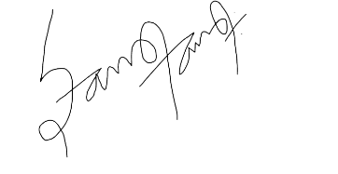

 Signature: ……………………………        Date: 7th May, 2021

(Must include the unedited statement above. Sign and date)

Please use an electronic signature (scan and insert)